**Figure A**. The age distributions of HPV vaccinated patients among different genders, races, and ethnicities groups.

1. Male patients who have started HPV vaccination.
2. Black people who have started HPV vaccination.
3. Asian people who have started HPV vaccination.
4. Non-Hispanic people who have started HPV vaccination.
5. Hispanic people who have started HPV vaccination.

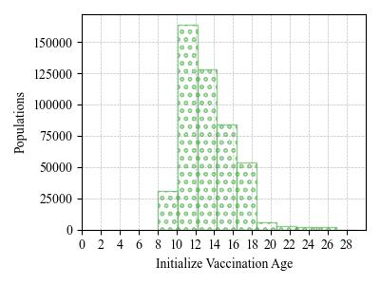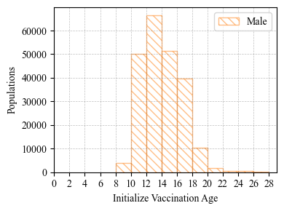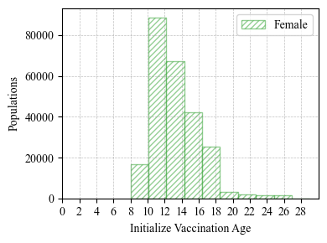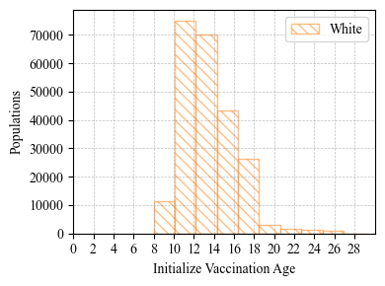

1. White people who have started HPV vaccination.

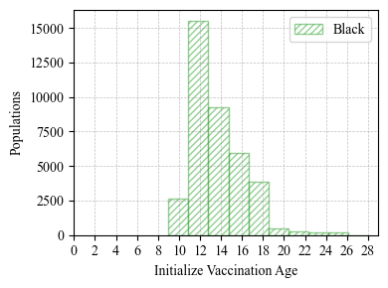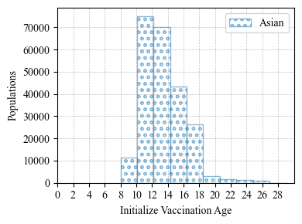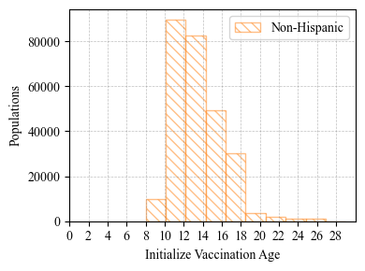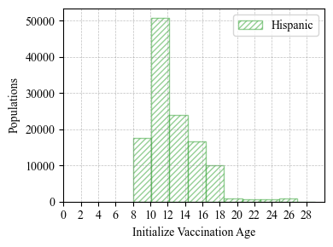

1. Female patients who have started HPV vaccination.
2. All patients who have started HPV vaccination.